**“Experiment 3.2”**

Student Name: **SUMIT KUMAR** UID: **20BCS8226**

Branch: **CSE** Section/Group: **808 A**

Semester: **5** Date of Submission: **12-11-22**

Subject Name: **Multimedia Technologies Lab**  Subject Code: **20CSP-339**

**Aim:**

Draw a circle to represent a drum and edit as required on one layer. Insert another layer, draw suitable drumsticks and position them appropriately. Give visual effects. Also provide an audio effect by selecting the sound item from Flash library Sounds.fla, so as to integrate audio and video clips using Macromedia flash.

**Hardware Requirements:**

Minimum 384MB RAM, 100 GB hard Disk, processor with 2.1 MHz

**Software Requirements:**

Macromedia flash 8

**Steps for the experiment:**

1. Open Macromedia Flash 8.
2. Create a new Flash Document.

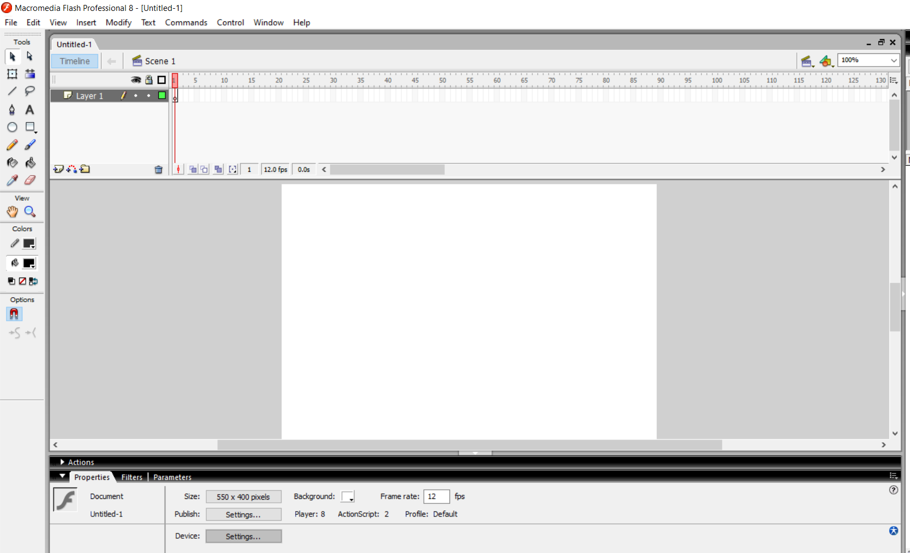

1. Draw a drum using oval, line and other necessary tools.

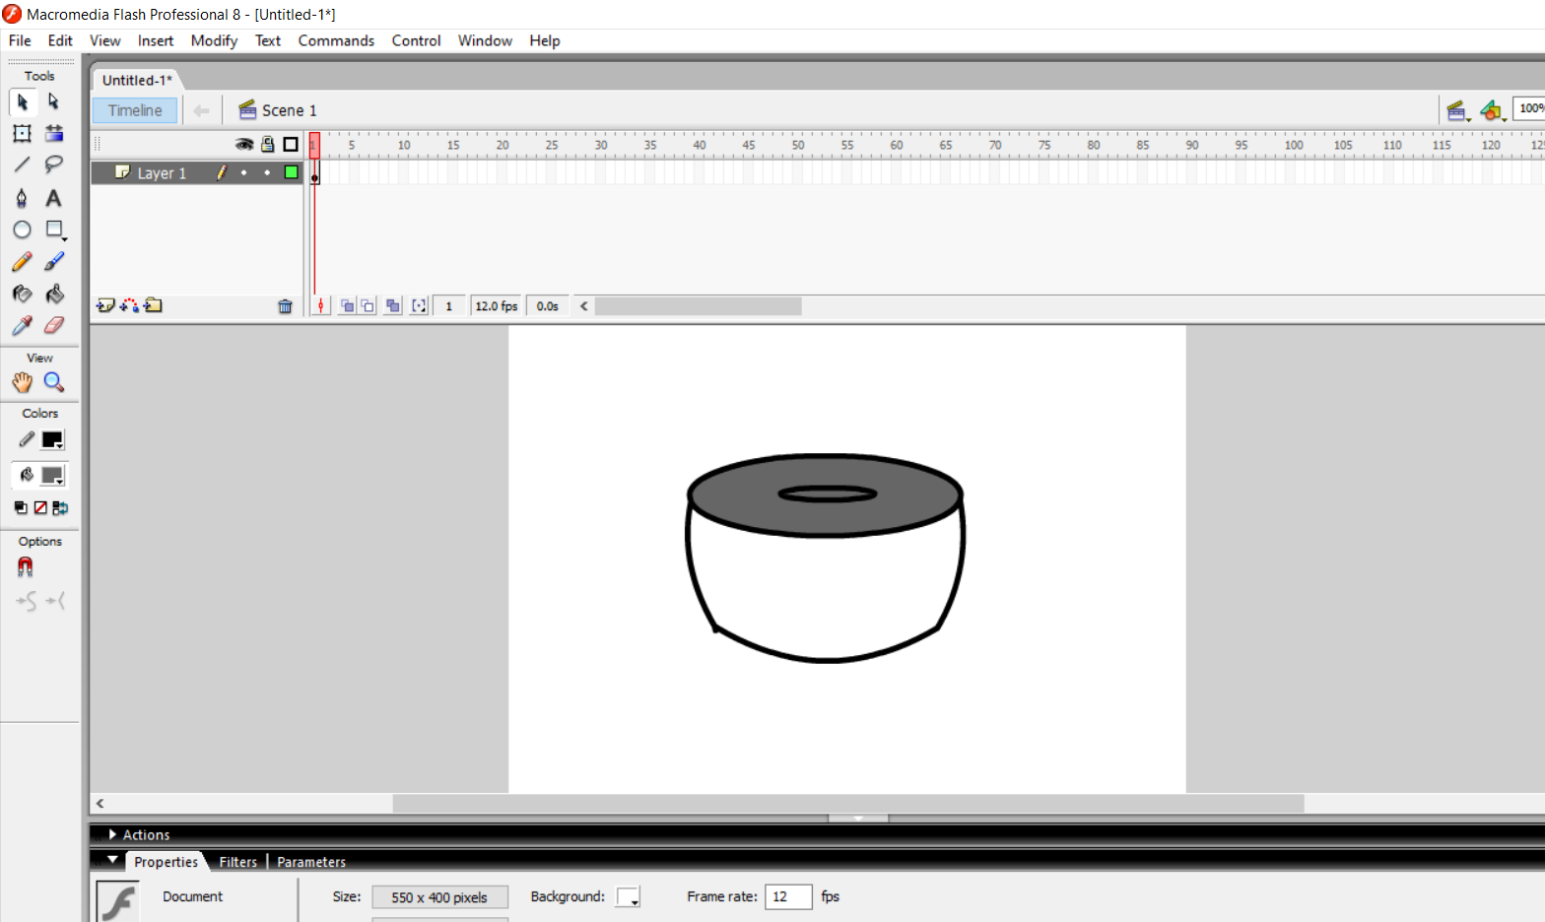

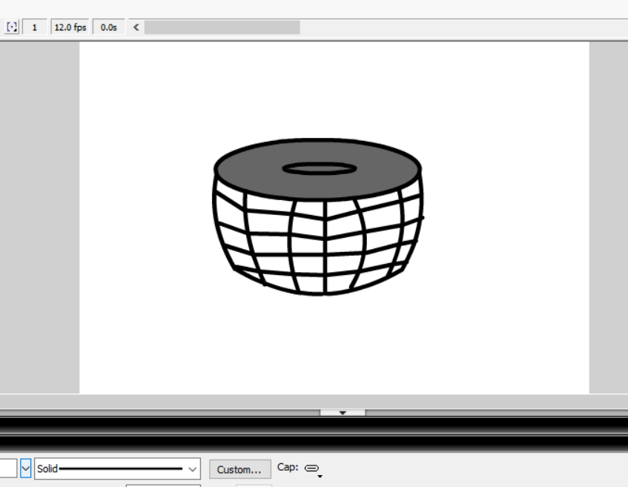

1. Insert a keyframe.

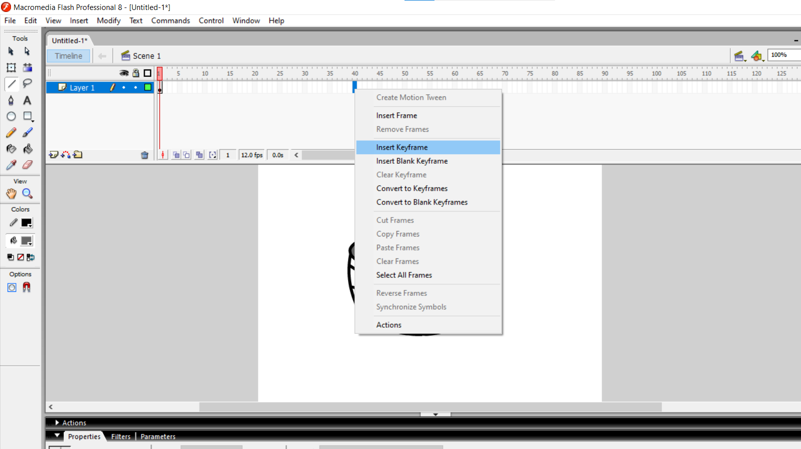

1. Rename the first layer as drum and insert a new layer and name it as sticks.

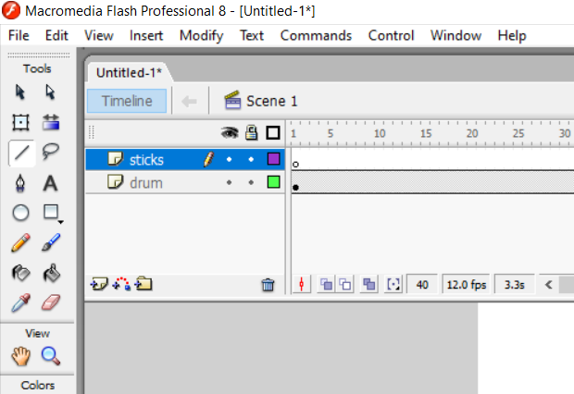

1. Now select the layer named as sticks and make drum sticks using rectangle and oval tool.

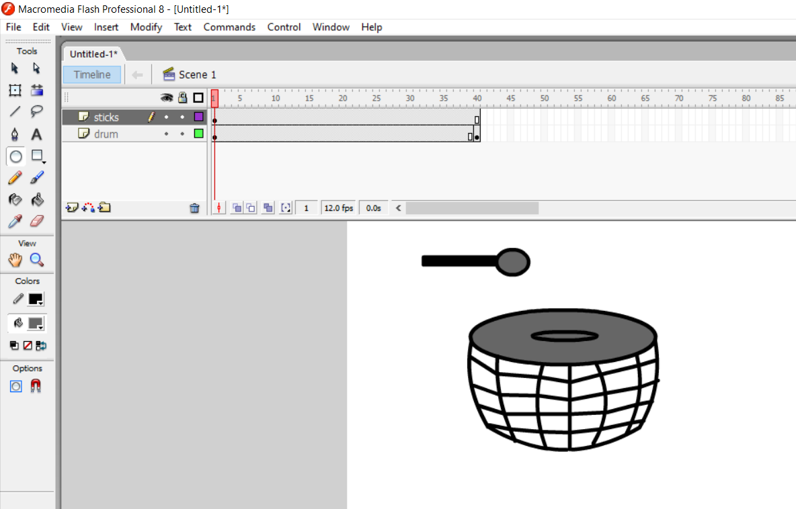

1. Now with the help of free transform tool rotate your drum stick towards the drum.

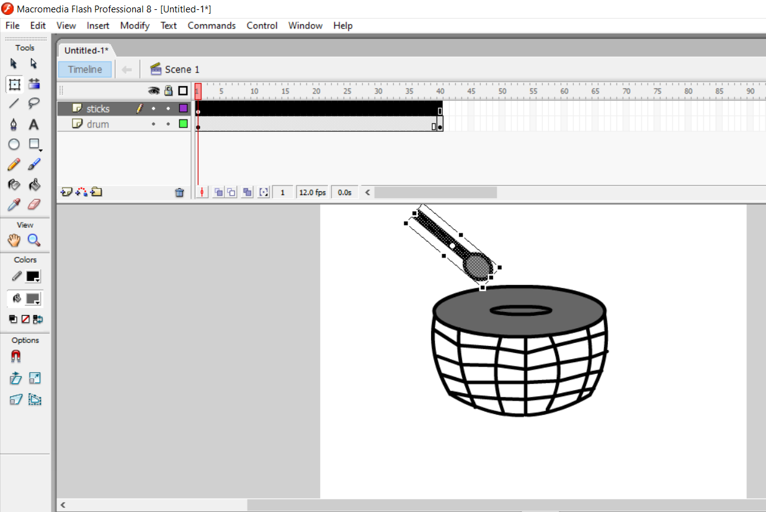

1. Now select the drum stick go to modify🡪group.

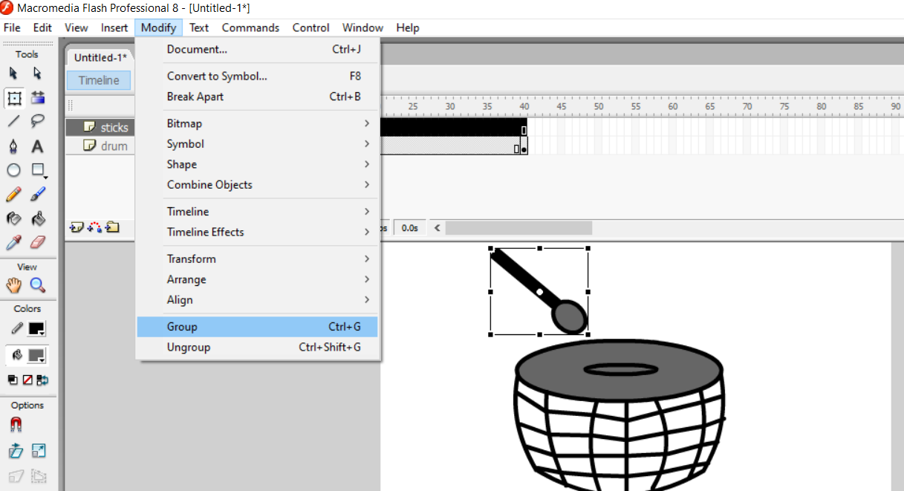

1. Now select the stick and right click on it and convert it into symbol.

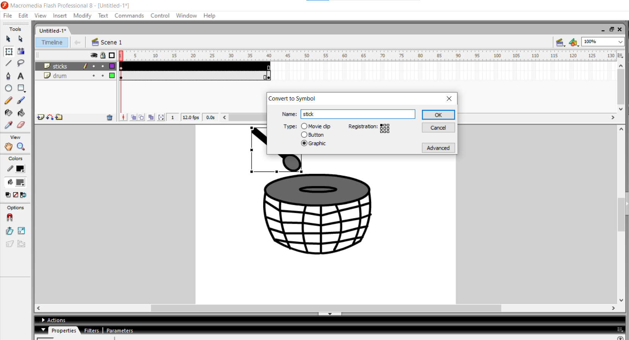

1. Copy the first stick and make another stick using paste option.

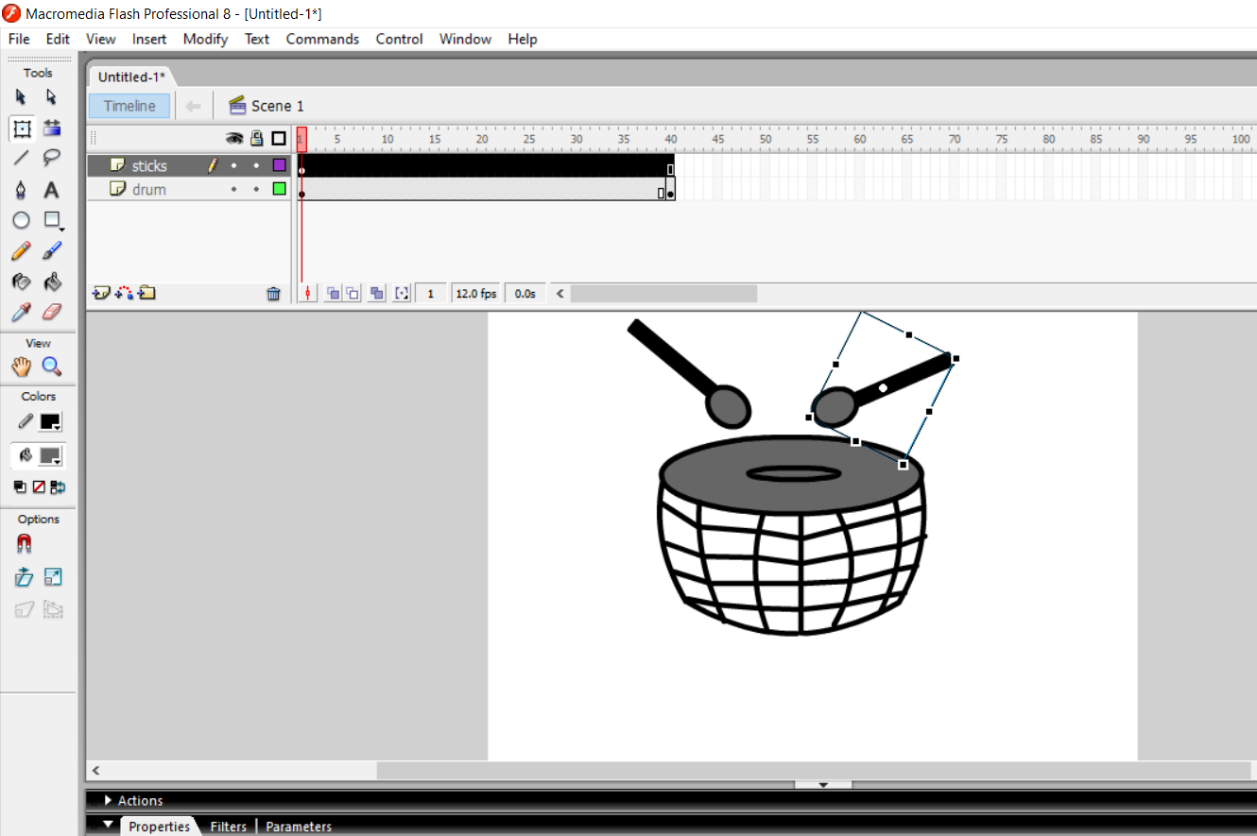

1. Click on the any number in timeline and right click and select insert keyframe.

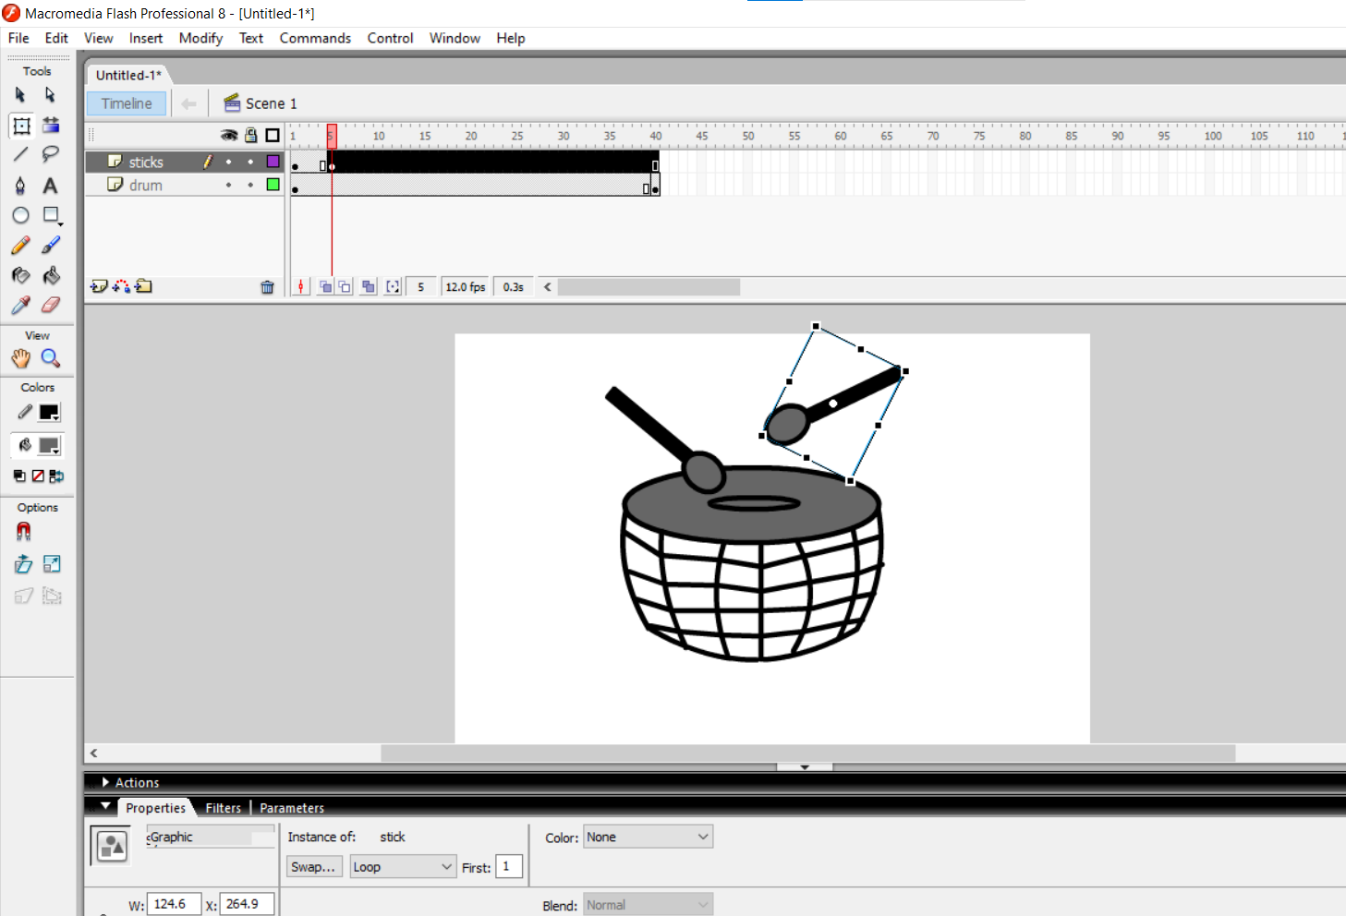

1. Do the above process again to make the sticks look like in a motion of beating the drum and insert keyframe for each motion on successive number in timeline.

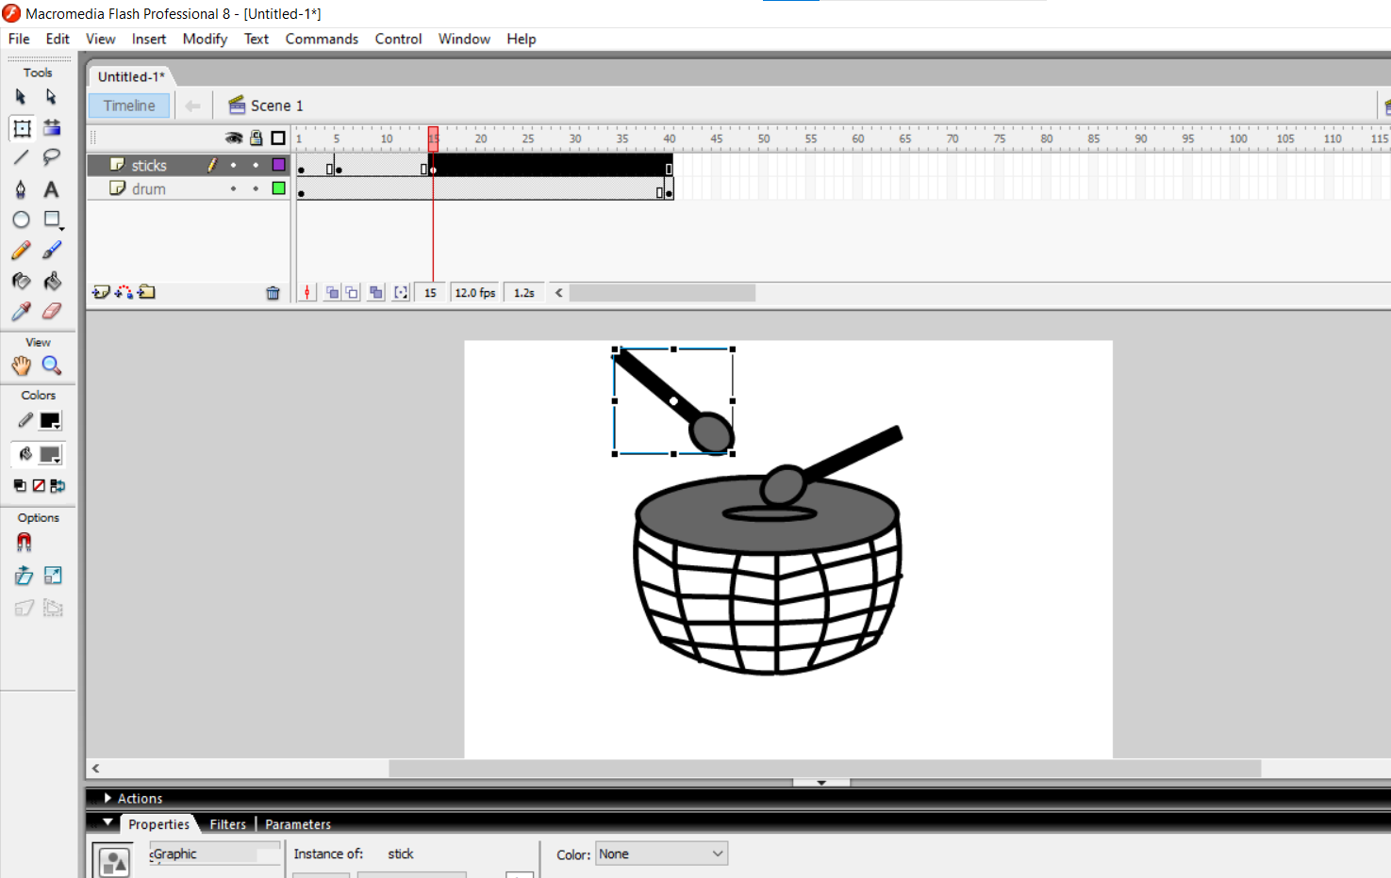

1. The final drumsticks are moving.

To add sound goto file 🡪 import 🡪import to library.

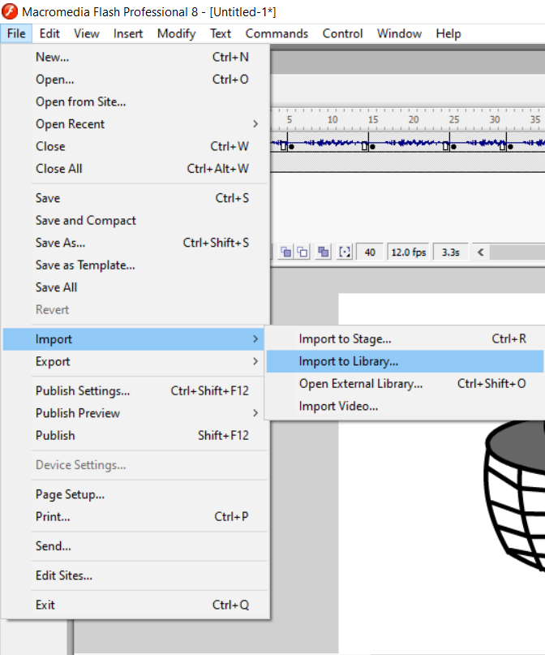

1. Select the downloaded drum beat sound (.wav) and add it to the library.

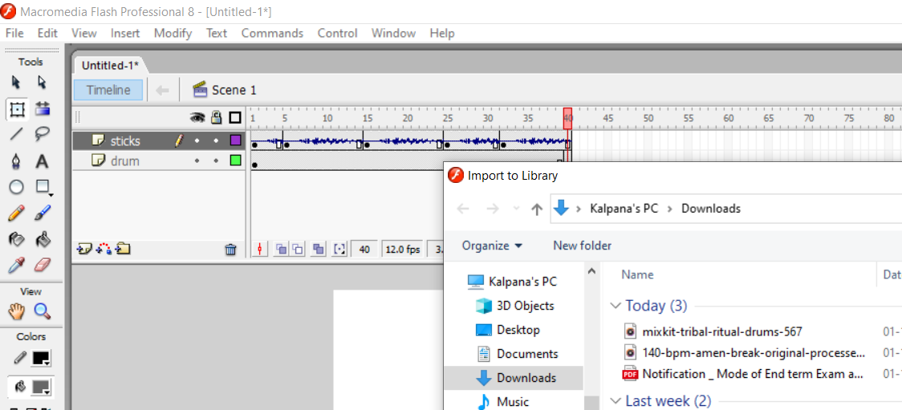

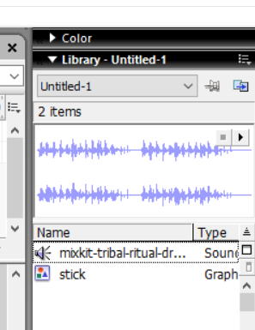

1. Select the music file from the library and drag it on the sticks you will see that music is added in your keyframe. Select the whole frame to add music to the whole frame.

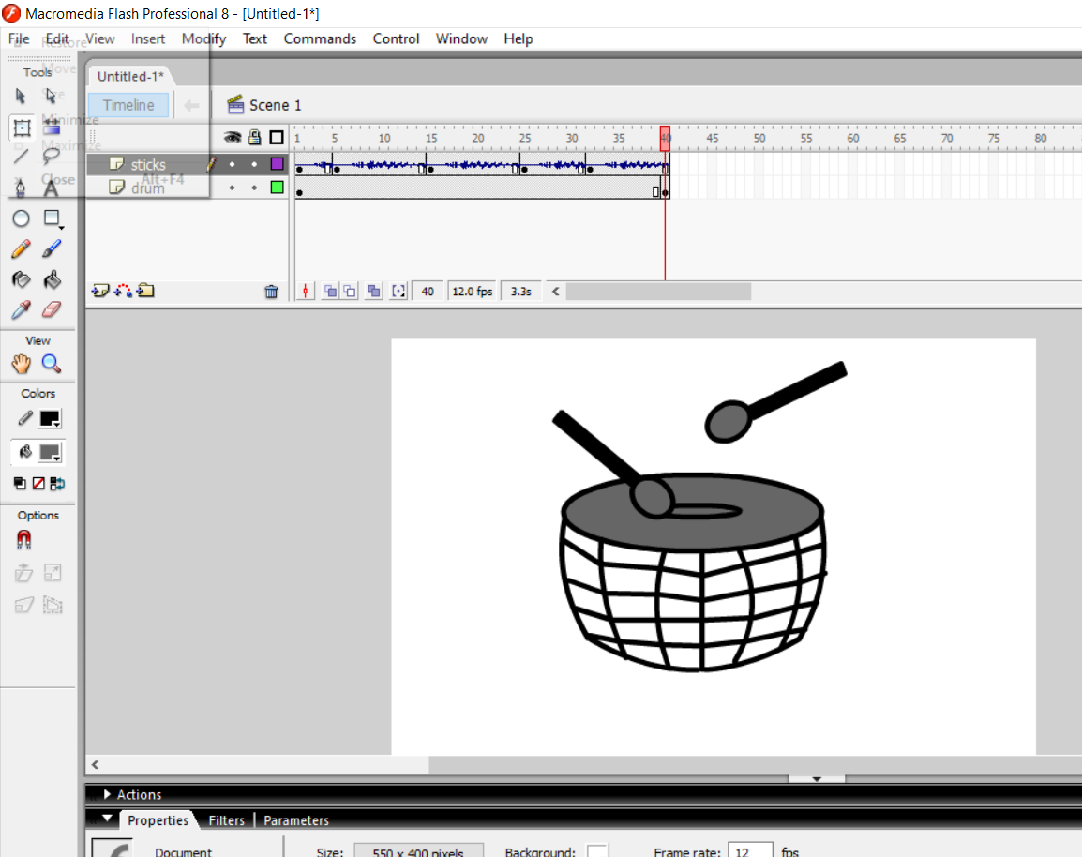

1. It is the final drum beating with sound.

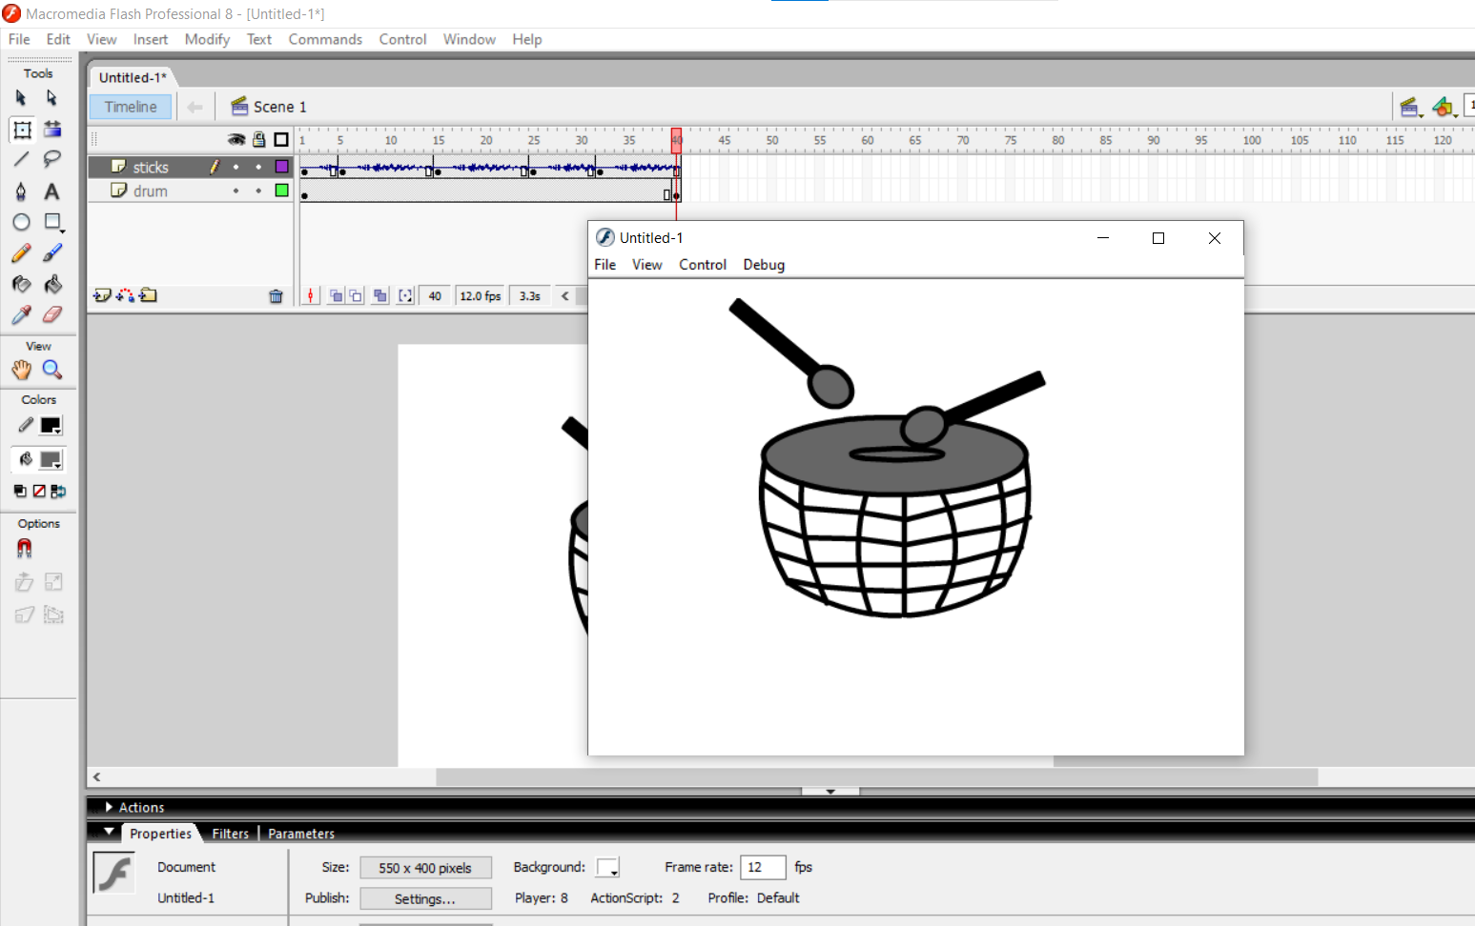

**Learning outcomes (What I have learnt):**

**1.** Learnt how to install macromedia flash.

**2.** Learnt the different features of macromedia flash.

**3.** Learnt about uses of different tools.

**4.** Learnt how to make animations using macromedia flash.

**Evaluation Grid (To be created as per the SOP and Assessment guidelines by the faculty):**

|  |  |  |  |
| --- | --- | --- | --- |
| Sr. No. | Parameters | Marks Obtained | Maximum Marks |
| 1. |  |  |  |
| 2. |  |  |  |
| 3. |  |  |  |
|  |  |  |  |